v = [1 2 3 4]
v =
1 2 3 4
v = [1; 2; 3; 4;]
v =
1
2
3
4
v(end-1)
ans =
3
m = [1 2 3; 6 5 2; 7 5 3]
m =
1 2 3
6 5 2
7 5 3
q = 1.602e-19
q =
1.6020e-19
a = 6.023e23
a =
6.0230e+23
mypi = 3.1415
mypi =
3.1415
numstates = 50
numstates =
50
year = 2023

year =
2023
j2 = [5 6 7 8];
m'
ans =
1 6 7
2 5 5
3 2 3
j = 1:10
j =
1 2 3 4 5 6 7 8 9 10
j = (1:10)'
j =
1
2
3
4
5
6
7
8
9
10
j2 = 0:.2:3
j2 =
0 0.2000 0.4000 0.6000 0.8000 1.0000 1.2000 1.4000 1.6000 1.8000 2.0000 2.2000 2.4000 2.6000 2.8000 3.0000
help colon;
m(1,:)
ans =
1 2 3
m(:,1)
ans =
1
6
7
m(1,1:2:end)
ans =
1 3
M = rand(6,6)
M =
0.8147 0.2785 0.9572 0.7922 0.6787 0.7060
0.9058 0.5469 0.4854 0.9595 0.7577 0.0318
0.1270 0.9575 0.8003 0.6557 0.7431 0.2769
0.9134 0.9649 0.1419 0.0357 0.3922 0.0462
0.6324 0.1576 0.4218 0.8491 0.6555 0.0971
0.0975 0.9706 0.9157 0.9340 0.1712 0.8235
M(1:2:end,1)
ans =
0.8147
0.1270
0.6324
M(2:2:end,2)
ans =
0.5469
0.9649
0.9706
M(1:2:end,:)
ans =
0.8147 0.2785 0.9572 0.7922 0.6787 0.7060
0.1270 0.9575 0.8003 0.6557 0.7431 0.2769
0.6324 0.1576 0.4218 0.8491 0.6555 0.0971

M(1:2:end,1:2:end)
ans =
0.8147 0.9572 0.6787
0.1270 0.8003 0.7431
0.6324 0.4218 0.6555
M(1:2:end,2:2:end)
ans =
0.2785 0.7922 0.7060
0.9575 0.6557 0.2769
0.1576 0.8491 0.0971
zeros(3,4)
ans =
0 0 0 0
0 0 0 0
0 0 0 0
doc zeros
zeros(4)
ans =
0 0 0 0
0 0 0 0
0 0 0 0
0 0 0 0
A = [1 4; 2 5; 3 6];
sz = size(A);
X = zeros(sz)
X =
0 0
0 0
0 0
f = 7 * ones(5,6)
f =
7 7 7 7 7 7
7 7 7 7 7 7
7 7 7 7 7 7
7 7 7 7 7 7
7 7 7 7 7 7
doc ones
ones(5)
ans =
1 1 1 1 1
1 1 1 1 1
1 1 1 1 1
1 1 1 1 1
1 1 1 1 1
x = ones(sz)
x =
1 1
1 1
1 1
rand(2,2)
ans =
0.6948 0.9502
0.3171 0.0344
doc rand
r = -5 + (5+5)*rand(10,1)
r =
-0.6126
-1.1844
2.6552
2.9520
-3.1313
-0.1024
-0.5441
1.4631
2.0936
2.5469
r = randi([10 50],1,5)
r =
21 37 36 16 14
randn(2,2)
ans =
-0.0068 -0.7697
1.5326 0.3714
doc randn
r = randn(5)
r =
-0.2256 1.1006 -1.0616 0.8886 -0.1774
1.1174 1.5442 2.3505 -0.7648 -0.1961
-1.0891 0.0859 -0.6156 -1.4023 1.4193
0.0326 -1.4916 0.7481 -1.4224 0.2916
0.5525 -0.7423 -0.1924 0.4882 0.1978
mu = [1 2];
sigma = [1 0.5; 0.5 2];
R = chol(sigma);
Z = repmat(mu,10,1) + randn(10,2)*R
Z =
2.5877 6.2141
0.1955 0.7156
1.6966 2.5961
1.8351 2.3084
0.7563 -0.6790
1.2157 1.5271
-0.1658 -0.9571
-0.1480 2.5377
1.1049 0.8777
1.7223 2.4935
clear j i
doc format
format long
pi
ans =
3.141592653589793
format hex
intmax('uint64')
ans =
ffffffffffffffff
x = 3;
y = 7;
z1 = x*y;
z2 = x/y;
z3 = x + y
z3 =
4024000000000000
z4 = mod(7,3);
r = 3;
vol = 4/3 * pi * r^3;
v1 = [10 11 12 13];
v2 = [45 23 12 10];
vsum = v1 + v2
vsum = 404b800000000000 4041000000000000 403800000000000 4037000000000000
format long
v3 = [20; 19; 18];
mv = m * v3

mv =
112
251
289 vprod = v1 .* v2
vprod =
450 253 144 130
j1 = 4
j1 =
4
e = 1/3;
j1sqrt = j1^e
j1sqrt =
1.587401051968199
j1 = 1:5;
j2 = j1 .^2
j2 =
1 4 9 16 25
j3 = 1:5;
j4 = (3/2) .^j;
j4 = (3/2) .^j
j4 = 0.918919036439500 + 0.394446199714361i
x = 2;
y = sin(x)
y = 0.909297426825682
xv = [2:.1:3];
yv = sin(xv)
yv = 0.909297426825682 0.863209366648874 0.808496403819590 0.745705212176720 0.675463180551151 0.598472144103956 0.515501371821464 0.427379880233830 0.334988150155905 0.239249329213982 0.141120008059867
zv = exp(xv)
zv = 7.389056098930650 8.166169912567650 9.025013499434122 9.974182454814718 11.023176380641601 12.182493960703473 13.463738035001692 14.879731724872837 16.444646771097048 18.174145369443060 20.085536923187668
lv = log(xv)
lv = 0.693147180559945 0.741937344729377 0.788457360364270 0.832909122935104 0.875468737353900 0.916290731874155 0.955511445027436 0.993251773010283 1.029619417181158 1.064710736992428 1.098612288668110
doc ops
doc power
A1 = 1:5;
c = A.^2
c =
1 16
4 25
9 36
c = A1.^2
c =
1 4 9 16 25
5^5
ans =
3125
doc mtimes
A1 = [1 1 0 0];
b = [1;2;3;4];
c = a * b
c =
1.0e+24 *
0.602300000000000
1.204600000000000
1.806900000000000
2.409200000000000
c = A1 * b
c =
3
c = b * a
c =
1.0e+24 *
0.602300000000000
1.204600000000000
1.806900000000000
2.409200000000000
c = b * A1
c =
1 1 0 0
2 2 0 0
3 3 0 0
4 4 0 0
doc times
a1 = [1 0 3];
b1 = [2 3 7];
c = a1 .* b1
c =
2 0 21
a1 = 1:3;
b1 = (1:4)';
a1 .* b1
ans =
1 2 3
2 4 6
3 6 9
4 8 12
doc eig
e = eig(m)
e =
10.710426283532634
-2.408272990792370
0.697846707259733
[V,D] = eig(m)
V =
0.345773254739993 0.724508473782354 0.399739782377922
0.612321198292902 -0.444586429899685 -0.780753609729636
0.710987768128016 -0.526716600997744 0.480241509324835
D =
10.710426283532634 0 0
0 -2.408272990792370 0
0 0 0.697846707259733
m * V - V*D
ans =
1.0e-14 *
0.088817841970013 0 -0.033306690738755
0.177635683940025 -0.222044604925031 -0.122124532708767
0.177635683940025 -0.155431223447522 -0.155431223447522
doc det
DET = det(m)
DET =
-18
doc inv
m1 =
-0.277777777777778 -0.500000000000000 0.611111111111111
0.222222222222222 1.000000000000000 -0.888888888888889
0.277777777777778 -0.500000000000000 0.388888888888889
b = [4;2;1] x = m\b
x =
-1.500000000000000
2.000000000000000
0.500000000000000
doc slash
e = exp(1);
(-sqrt(16)-4)/(2*e^4 + 1)
ans =
-0.072597718754510
k = (1:20);
k = k.^2;
sum(k)
ans =
2870
doc prod
temp = [1:3:7; 2:3:8;3:3:9];
temp2 = prod(temp)
temp2 =
6 120 504
doc cumsum
temp = 1:5;
temp2 = cumsum(temp)
temp2 =
1 3 6 10 15
doc diff
temp = [1 1 2 3 4 8 13 21];
temp2 = diff(temp)
temp2 =
0 1 1 1 4 5 8
doc plot
j = (1:51);
x = sin(2*pi*j/50);
y =cos(6*pi*j/50);
plot(x,y)
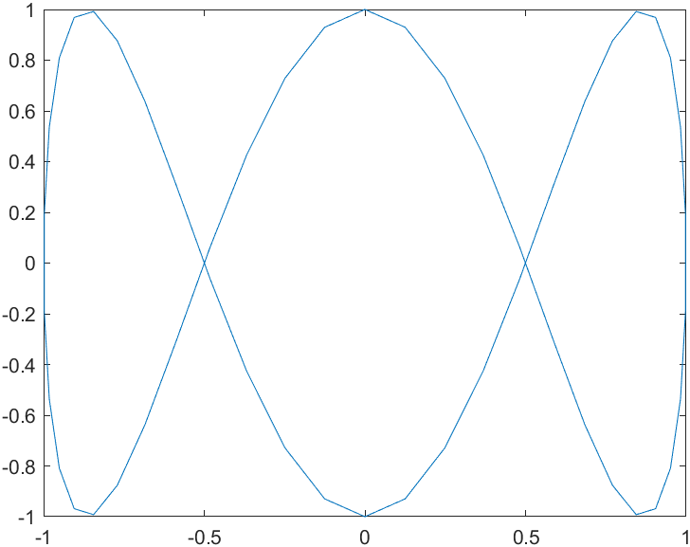
plot(j,x)
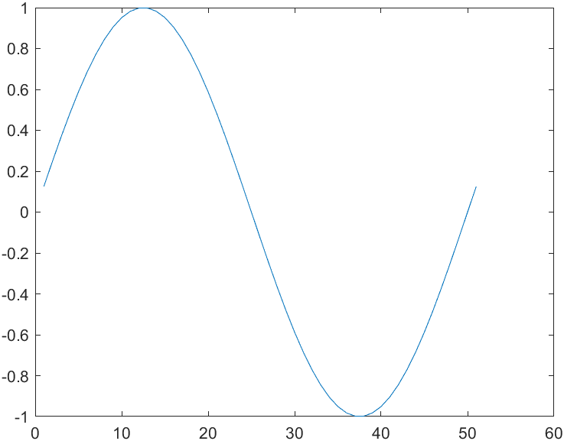
x = 0: .01: pi;
plot(x,sin(x));
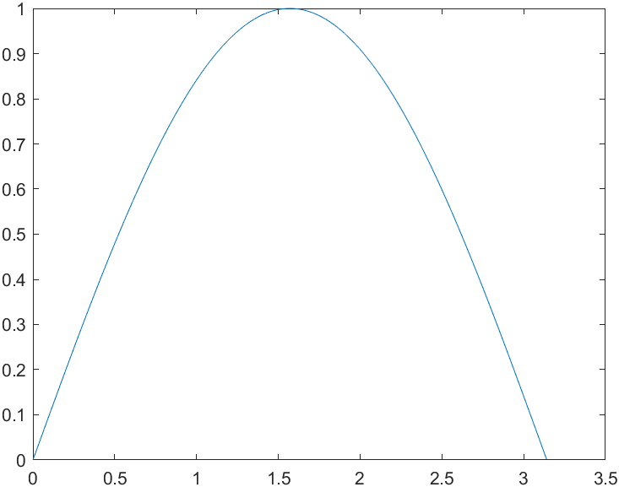
x1 = -2:.01:2;
y = x1.^2;
x2 = -3:.01:3;
z = x2.^3;
plot(x1,y,x2,z);
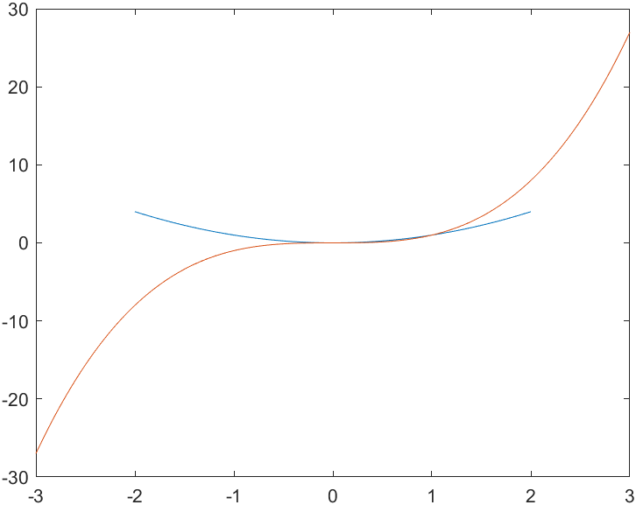
plot(x1,y,'r:',x2,z,'c--');
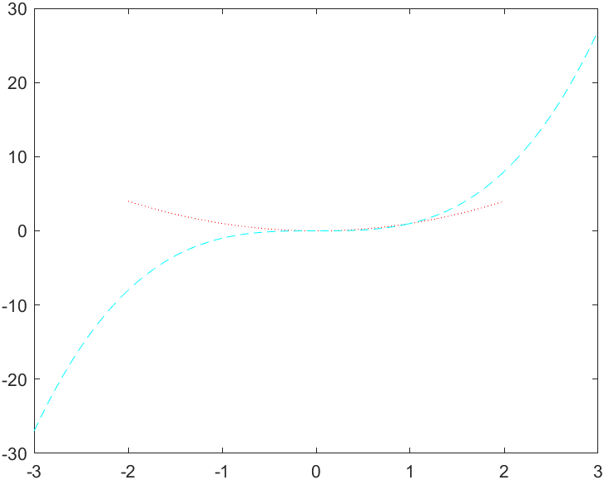
doc subplot
subplot(2,1,1);
plot(x1,y,'r:');
subplot(2,1,2);
plot(x2,z,'c--');
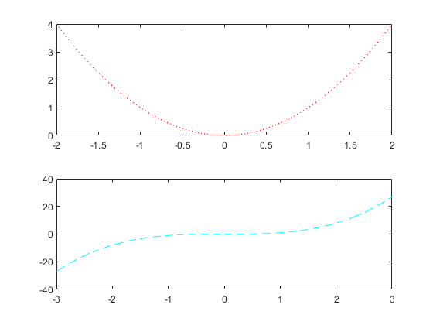
doc figure f = figure
f =
<a href="matlab:helpPopup matlab.ui.Figure" style="font-weight:bold">Figure</a> (3) with properties:
Number: 3
Name: ''
Color: [0.940000000000000 0.940000000000000 … ]
Position: [403 146 560 420]
Units: 'pixels'
Show <a href="matlab:if exist('f', 'var'), matlab.graphics.internal.getForDisplay('f', f, 'matlab.ui.Figure'), else, matlab.graphics.internal.getForDisplay('f'), end">all properties</a>
f.Position
ans =
403 146 560 420
f.Position(3:4) = [280 210];
doc xlabel
plot((1:10).^2)
xlabel('population');
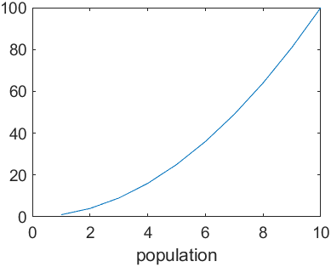
doc ylabel
ylabel('population');
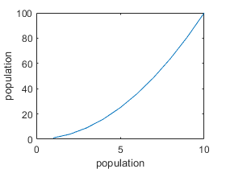
doc title
title('My Title');
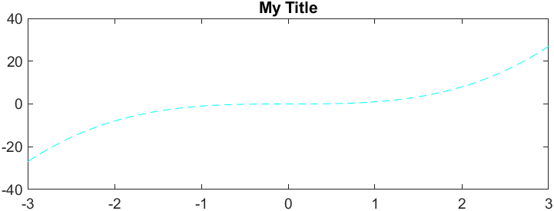
doc stem
f = figure
f =
<a href="matlab:helpPopup matlab.ui.Figure" style="font-weight:bold">Figure</a> (2) with properties:
Number: 2
Name: ''
Color: [0.940000000000000 0.940000000000000 … ]
Position: [403 146 560 420]
Units: 'pixels'
Show <a href="matlab:if exist('f', 'var'), matlab.graphics.internal.getForDisplay('f', f, 'matlab.ui.Figure'), else, matlab.graphics.internal.getForDisplay('f'), end">all properties</a>
Y = linspace(-2*pi,2*pi,50);
stem(Y)
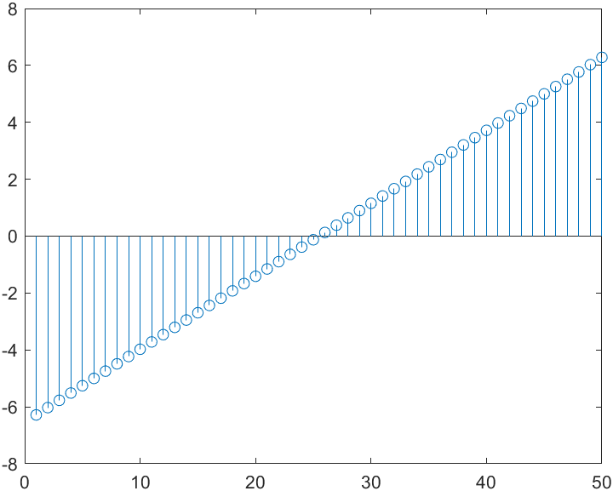
doc semilogy
x = 1:100;
y = x.^2;
semilogy(x,y);
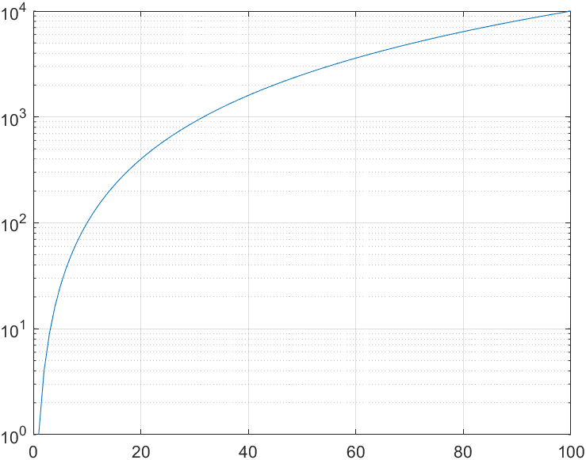
grid on
doc semilogx
x = logspace(-1,2);
y = x;
semilogx(x,y)
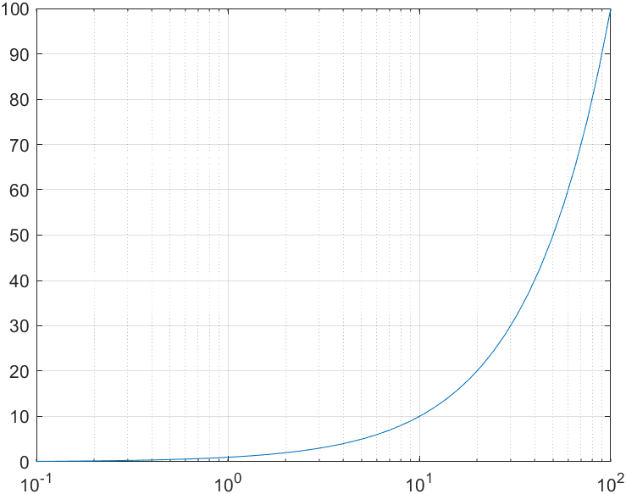
grid on
doc loglog
x = logspace(-1,2);
y = 2.^x;
loglog(x,y)
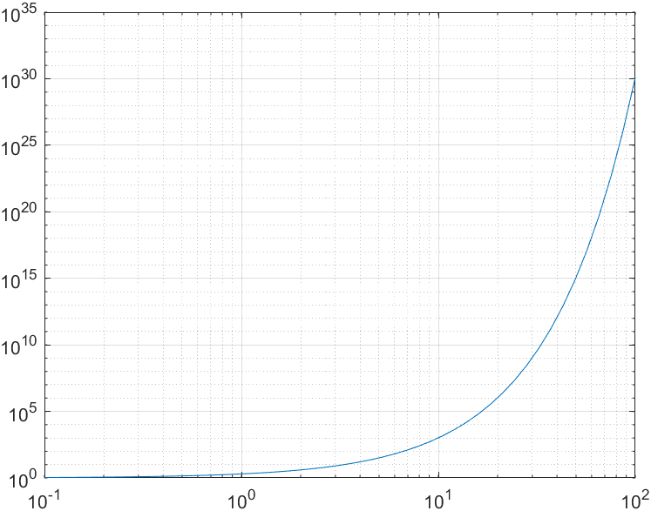
grid on
doc text
x = 0:pi/20:2*pi;
y = sin(x);
plot(x,y)
text(pi,0,'\leftarrow sin(\pi)')
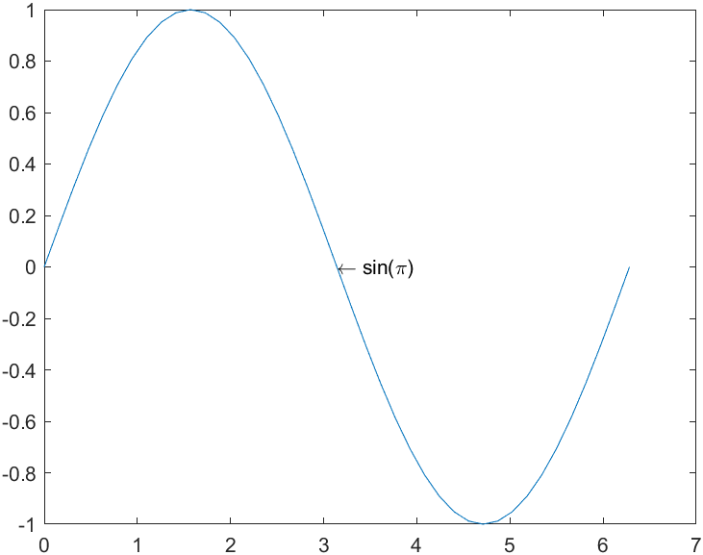
doc print
bar(1:10)
print
AT END OF DOCUMENT
doc get
doc set
ezplot('sin(x)')
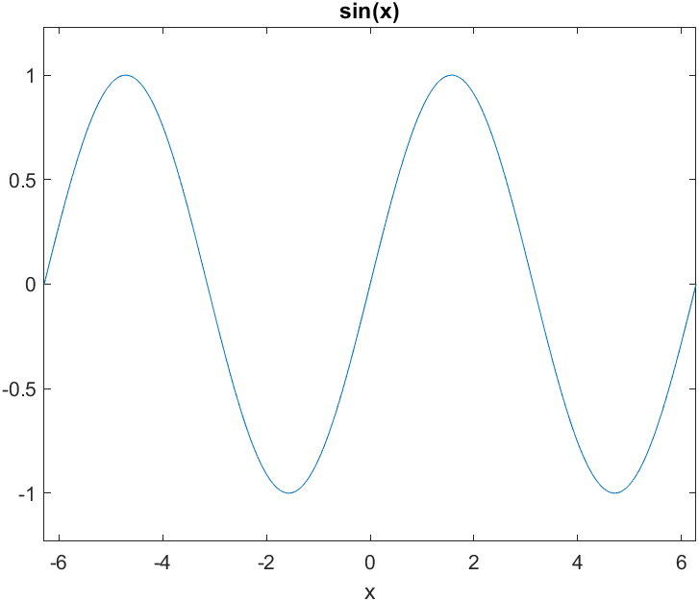
doc ezplot
ezplot('x^2')
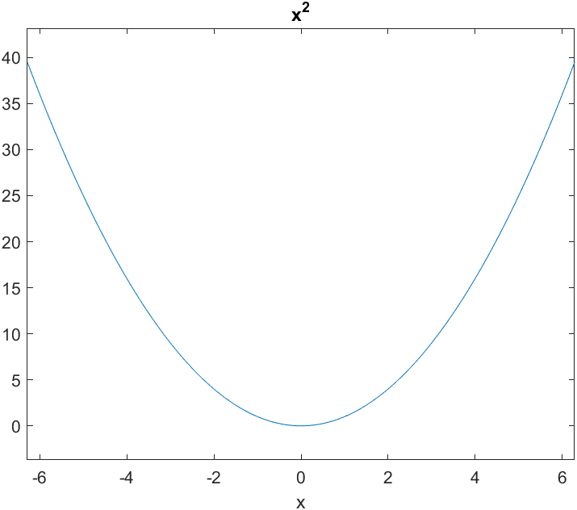
help help
lookfor binomial
edit myfile.m
pwd
ans =
'C:\Users\natew\Documents\continuous\Continuous programs\Matlab_tutorial'
myfile
done!
edit fact
f = fact(4)
f =
24
fact(5)
ans =
120
fact(10)
ans =
3628800
doc if
edit fact2.m
fact2(10)
ans =
3628800
doc for
doc while
doc do/while edit dec2bin.m
edit dectobin.m
b = dectobin(10)
b =
1 0 1 0 b = dectobin(101)
b =
1 1 0 0 1 0 1
b = dectobin(15)
b =
1 1 1 1
b = dectobin(31)
b =
1 1 1 1 1
doc punct
doc function_handle
f = @(x) sin(x)./x;
f(1)
ans =
0.841470984807897
f(2)
ans =
0.454648713412841
x = .01:.01:20;
plot(x,f(x));
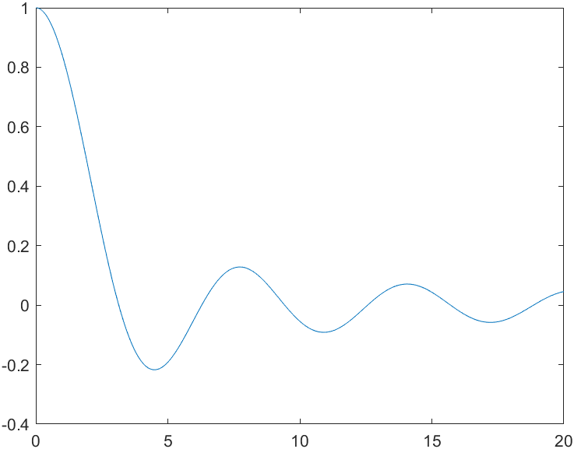
fact = @(n) prod([1:n]);
fact(4)
ans =
24
fact(100)
ans =
9.332621544394410e+157
doc fprintf
a = [1.02 3.04 5.06];
fprintf('%d\n',round(a));
1
3
5
doc fopen
doc fread
doc fclose
ID = fopen('nine.bin','w');
fwrite(ID,[1:9]);
fclose(ID);
ID = fopen('nine.bin');
a = fread(ID)
a =
1
2
3
4
5
6
7
8
9
doc save
doc load name = "test.mat";
save(name)
clear
load("test.mat")
M = rand(20,20);
imagesc(M);
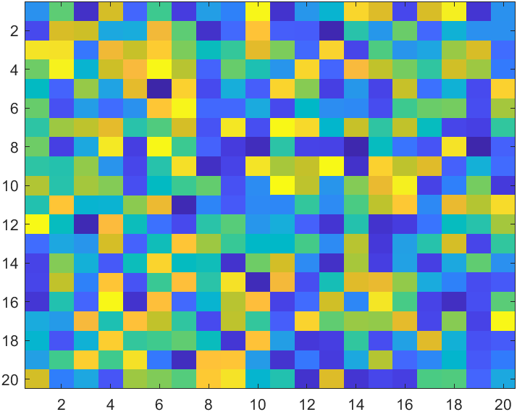
fs = 4000;
ts = 1/fs;
t = 0:ts:5;
y = sin(2 * pi * 400 * t);
sound(y,fs);
audiowrite('mysin400.wav',y,fs)
clear y
y = audioread('mysin400.wav');
sound(y,fs)
v = [1, 0, -10, 2]
v =
1 0 -10 2
rts = roots(v);
v1 = poly(rts)
v1 = 1.000000000000000 0.000000000000002 -9.999999999999998 2.000000000000000
quad('sin',0,5)
ans =
0.716337813168117
doc quad
myfun = @(x) 1./(x.^3-2*x-5);
q = quad(myfun,0,2)
q =
-0.460501739742492
doc symbolic
syms k n;
s1 = symsum(k^2,k,0,n)
s1 =
(n*(2*n + 1)*(n + 1))/6
s2 = expand(s1)
s2 =
n^3/3 + n^2/2 + n/6
subs(s2,n,20)
ans =
2870
syms t T n;
i1 = int(t*cos(2*pi*n*t),t,0,T)
i1 =
-(2*sin(pi*T*n)^2 - 2*T*n*pi*sin(2*pi*T*n))/(4*n^2*pi^2)
simplify(i1)
ans =
-(sin(pi*T*n)^2 - T*n*pi*sin(2*pi*T*n))/(2*n^2*pi^2)
syms e x;
e = (2*x^2 - 3*x + 1)/(x^3 + 2*x^2 - 9*x - 18)
e =
-(2*x^2 - 3*x + 1)/(- x^3 - 2*x^2 + 9*x + 18)
de = diff(e,x)
de =
- (4*x - 3)/(- x^3 - 2*x^2 + 9*x + 18) - ((2*x^2 - 3*x + 1)*(3*x^2 + 4*x - 9))/(- x^3 - 2*x^2 + 9*x + 18)^2
syms d m;
m = sym([d^2 2 7; d d^3 9; 1 5 1/d])
m =
[d^2, 2, 7]
[ d, d^3, 9]
[ 1, 5, 1/d]
det(m)
ans =
d^4 - 7*d^3 - 45*d^2 + 35*d + 16
inv(m)
ans =
[ (d^2 - 45)/(d^4 - 7*d^3 - 45*d^2 + 35*d + 16), (35*d - 2)/(d*(d^4 - 7*d^3 - 45*d^2 + 35*d + 16)), -(7*d^3 - 18)/(d^4 - 7*d^3 - 45*d^2 + 35*d + 16)]
[ 8/(d^4 - 7*d^3 - 45*d^2 + 35*d + 16), (d - 7)/(d^4 - 7*d^3 - 45*d^2 + 35*d + 16), (- 9*d^2 + 7*d)/(d^4 - 7*d^3 - 45*d^2 + 35*d + 16)]
[(- d^3 + 5*d)/(d^4 - 7*d^3 - 45*d^2 + 35*d + 16), -(5*d^2 - 2)/(d^4 - 7*d^3 - 45*d^2 + 35*d + 16), -(- d^5 + 2*d)/(d^4 - 7*d^3 - 45*d^2 + 35*d + 16)]
a = [1 2 -9 -18];
b = [2 -3 1];
[r,p] = residue(b,a)
r =
0.333333333333334
4.666666666666665
-3.000000000000000
p =
3.000000000000001
-3.000000000000000
-2.000000000000000
doc residue
syms x;
f = (2*x^2 - 3*x + 1)/(x^3 + 2*x^2 - 9*x-18);
pfe = diff(int(f))
pfe =
1/(3*(x - 3)) - 3/(x + 2) + 14/(3*(x + 3))
simplify(pfe)
ans =
1/(3*(x - 3)) - 3/(x + 2) + 14/(3*(x + 3))
num = 2*x^2 - 3 * x + 1
num =
2*x^2 - 3*x + 1
den = x^3 + 2 * x^2 - 9.4*x - 18
den =
x^3 + 2*x^2 - (47*x)/5 - 18
doc deconv
num2 = [2 -3 1];
den2 = [1 2 -9.4 -18];
[q,r] = deconv(num2,den2)
q =
0
r =
2 -3 1
syms x
f1 = (2*x^2 - 3*x + 1)/(x^3 + 2*x^2 - 9.4 * x - 18);
diff(int(f1))
ans =
-(5*(2*x^2 - 3*x + 1))/(- 5*x^3 - 10*x^2 + 47*x + 90)
simplify(ans)
ans =
-(5*(2*x^2 - 3*x + 1))/(- 5*x^3 - 10*x^2 + 47*x + 90)
r =
3.768777065276832
0.339943600900224
-2.108720666177055
p =
-3.175032623565353
3.039945414333275
-1.864912790767925

